**ASSIGNMENT-4**

U19CS012

**Design the below given circuits. Verify their Functionality with the help of Multisim.**

**1.** Full Adder using least number of NAND Gates.

*a.) Implement the circuit in Multisim online*

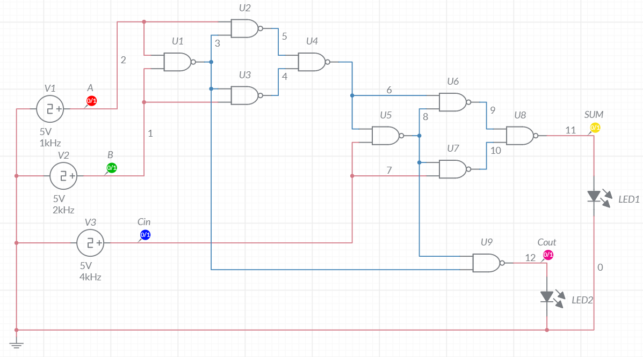

b.) Truth Table

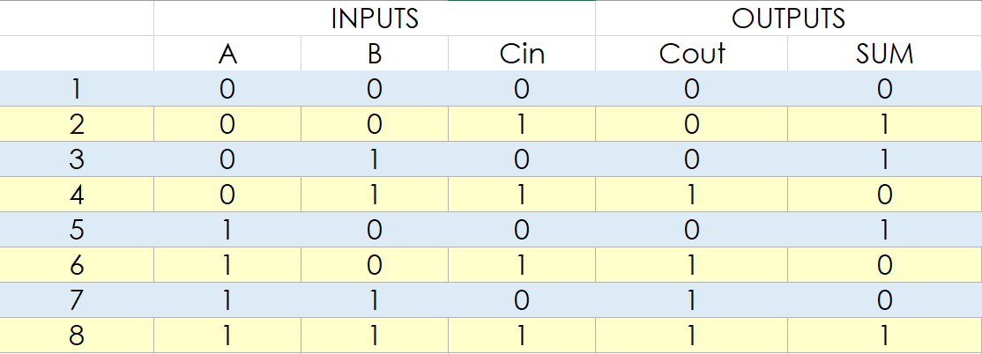

*c.) Timing Graph*

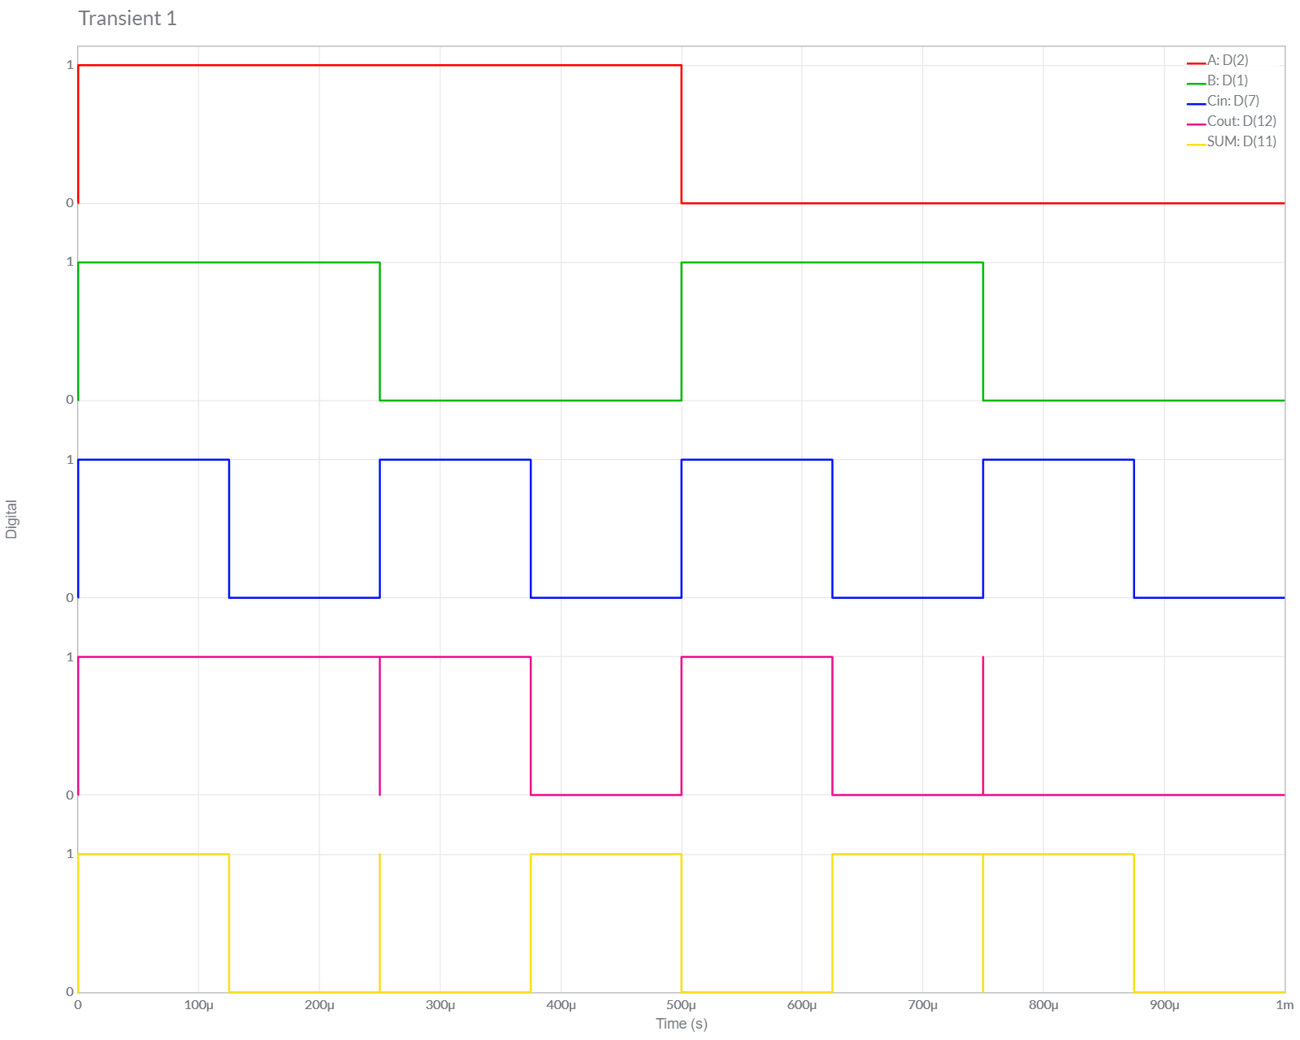

d.) Conclusion

We can observe from Above Graph and Truth Table, Both the *Theoretical* and *Multisim* Values of Given Circuit are **Equal**.

Hence, Experiment is Performed Successfully (without any Error) & Functionality of Circuit is verified.

**2.** Full Subtractor using least number of NOR Gates.

*a.) Implement the circuit in Multisim online*

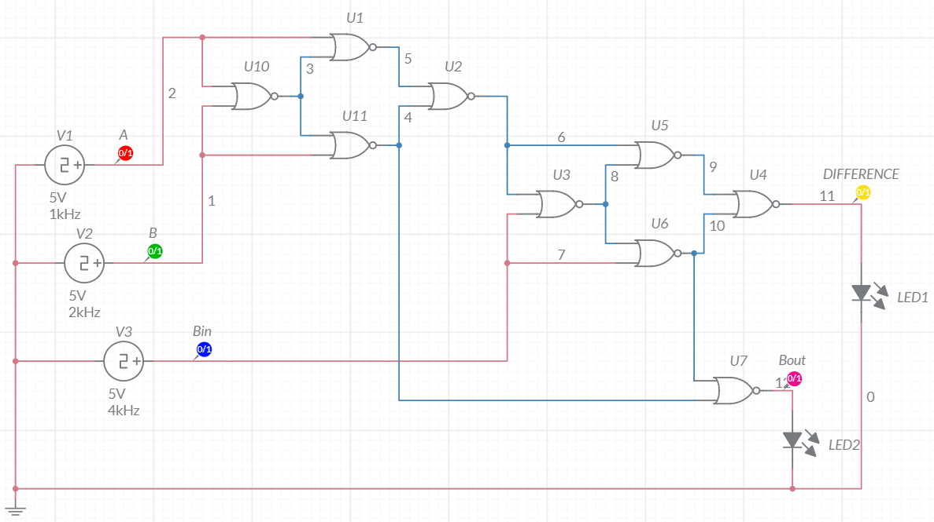

c.) Truth Table

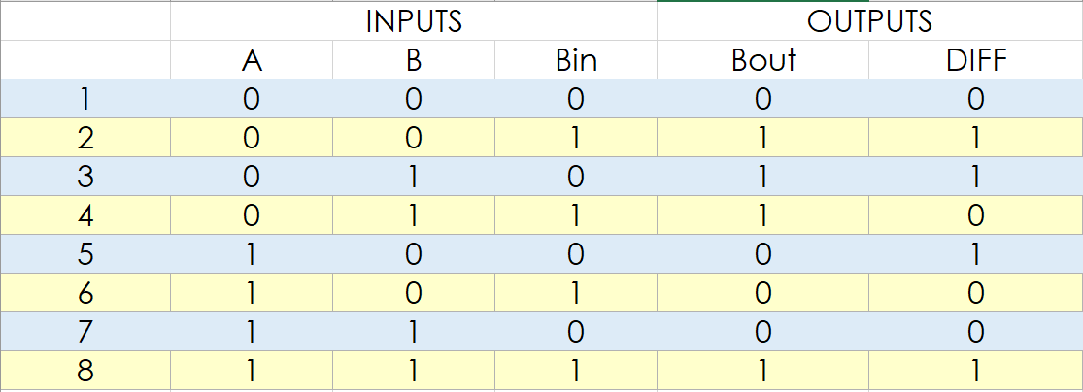

*b.) Timing Graph*

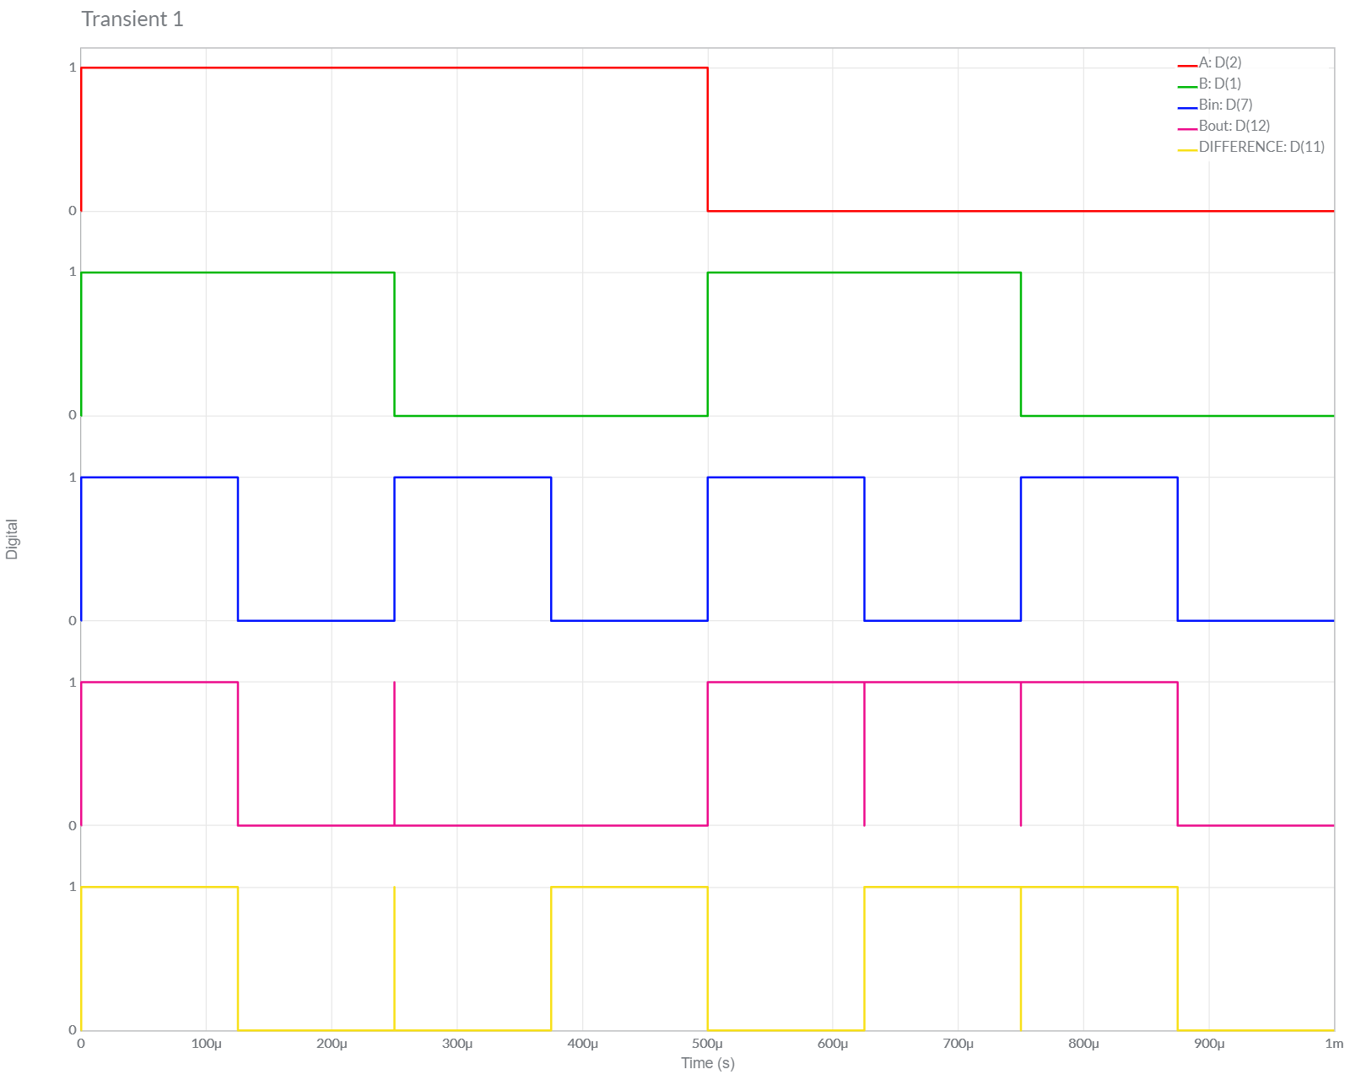

d.) Conclusion

We can observe from Above Graph and Truth Table, Both the *Theoretical* and *Multisim* Values of Given Circuit are **Equal**.

Hence, Experiment is Performed Successfully (without any Error) & Functionality of Circuit is verified.

**3.** Two bit Adder circuit using Full Adders. Attach screenshots for any four input combinations.

*a.) Implement the circuit in Multisim online [Using 2 Full Adders]*

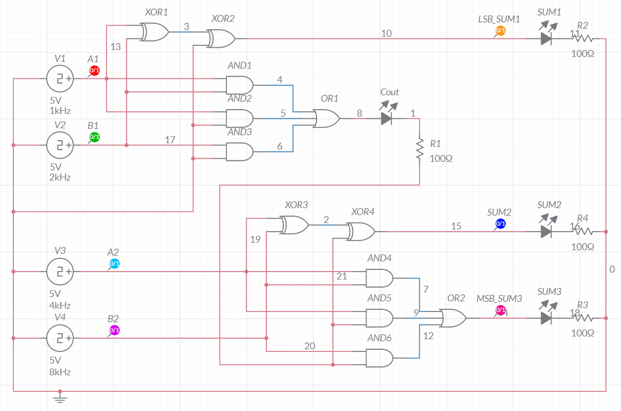

*b.) Implement the circuit in Multisim online [Using 1 Full Adders + 1 Half Adder] [Optimized]*

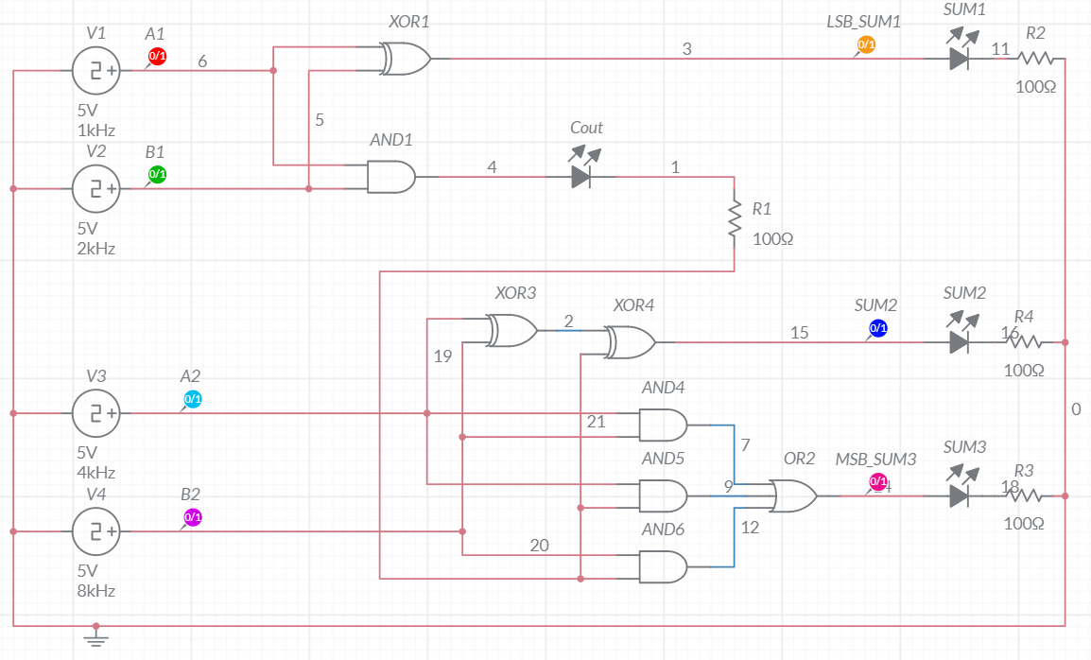

*c.) Timing Graph [Same for Both Circuit]*

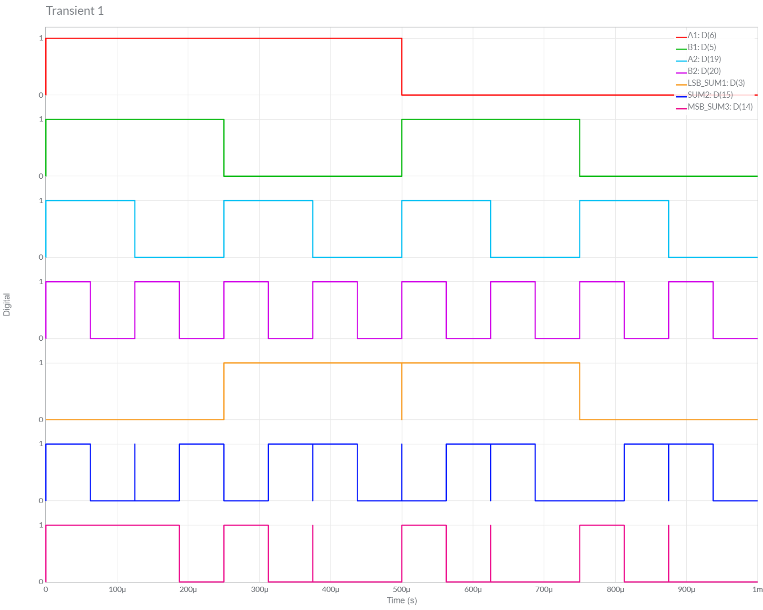

c.) Truth Table

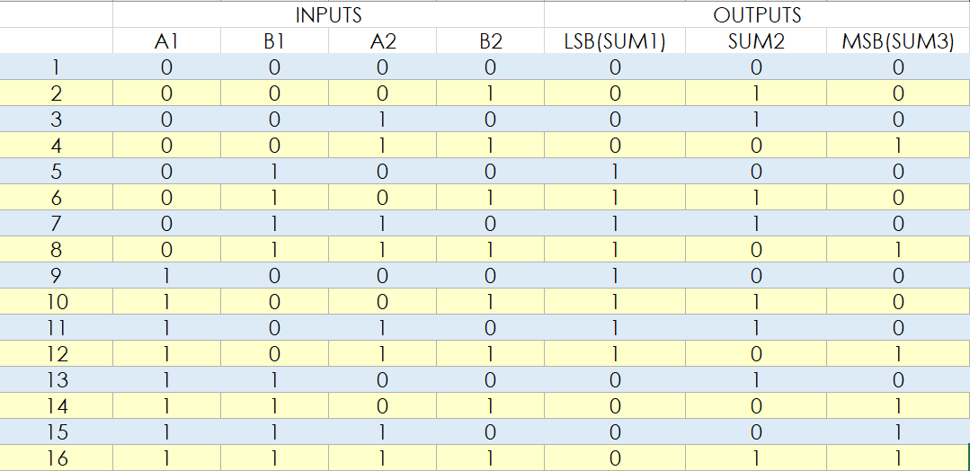

d.) Conclusion

We can observe from Above Graph and Truth Table, Both the *Theoretical* and *Multisim* Values of Given Circuit are **Equal**.

Hence, Experiment is Performed Successfully (without any Error) & Functionality of Circuit is verified.